**RELATIONAL DATABASE SERVICE (RDS)**

Amazon Relational Database Service (Amazon RDS) is a web service that makes it easier to set up, operate, and scale a relational database in the cloud.

It provides cost-efficient, resizeable capacity for an industry-standard relational database and manages common database administration tasks.

Amazon Aurora is a fully managed relational database engine that's built for the cloud and compatible with MySQL and PostgreSQL. Amazon Aurora is part of Amazon RDS.

**STEP 1: Create Instance**

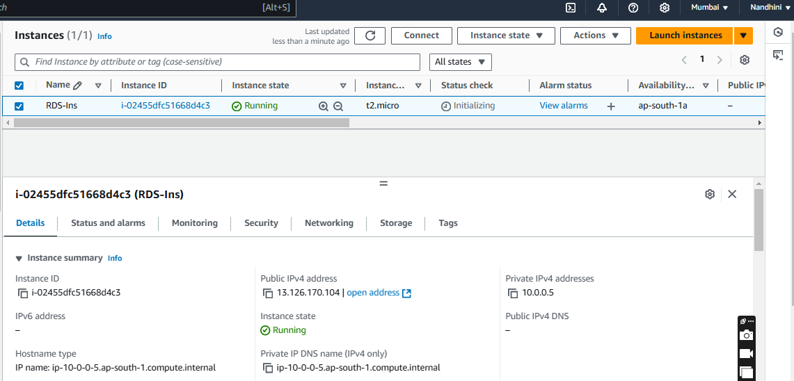

**Step 2: Create Subnet Group**

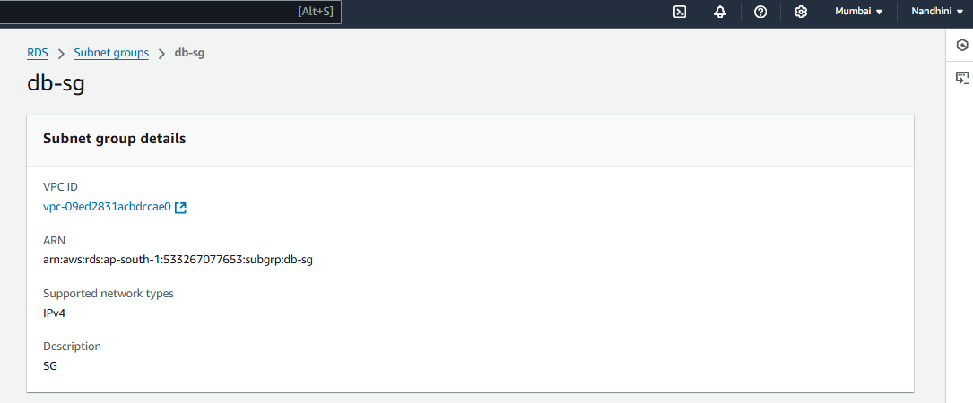

**Step 3: Create Database (MariaDB):**

MariaDB Community Edition is a MySQL-compatible database with strong support from the open source community, and extra features and performance optimizations.

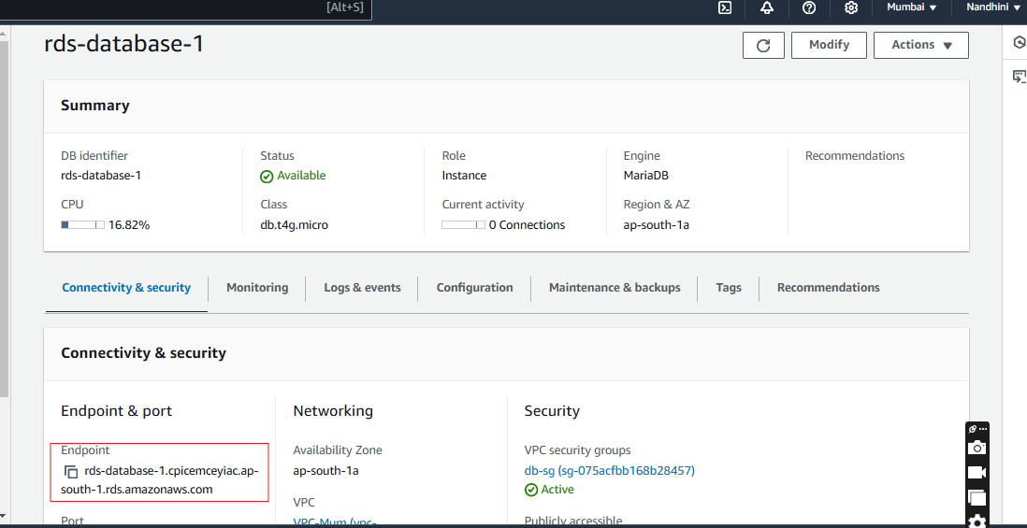

**Step 4: Login to Ubuntu instance, install and connect into MariaDB.**

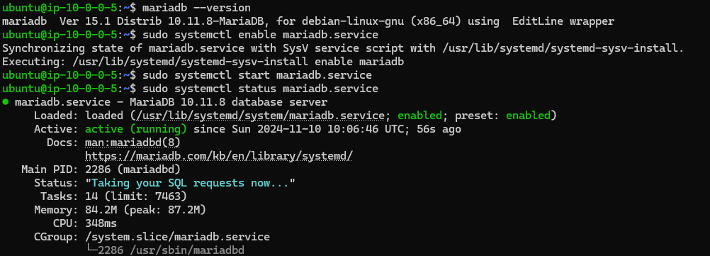

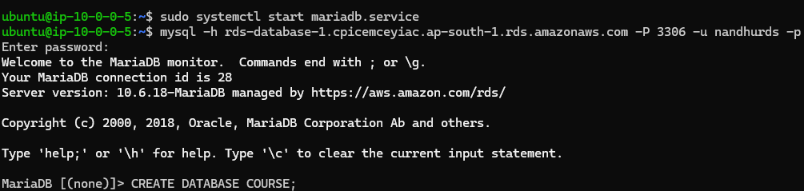

**Step 5: After connecting into Database, created a table using SQL Query**

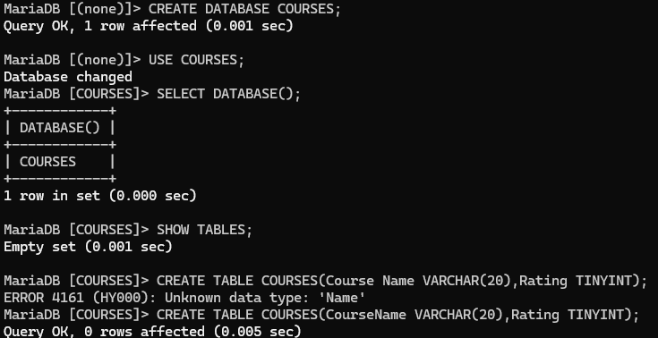

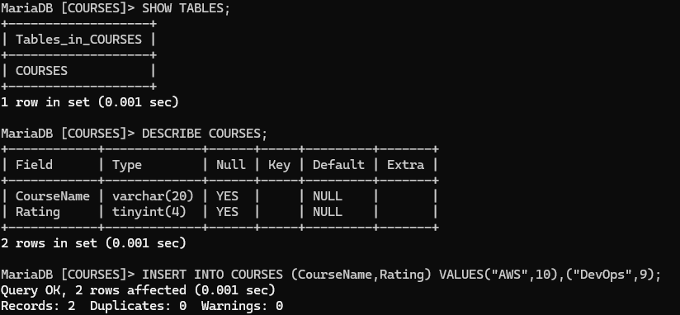

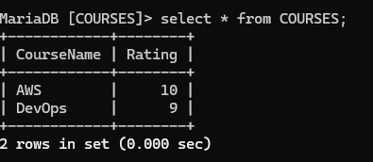

**SQL QUERY: To create a table:**

CREATE DATABASE COURSES;

USE COURSES;

SELECT DATABASE();

SHOW TABLES;

CREATE TABLE COURSES (CourseName VARCHAR(20), Rating TINYINT);

DESCRIBE COURSES;

INSERT INTO COURSES (CourseName, Rating) VALUES (“AWS”,10)(“DevOps”,9);

Select * from COURSES;